Chapter 6, Problem 53.

Find L_{eq} at the terminals of the circuit in Fig. 6.75.

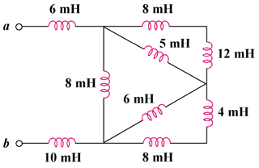

Figure 6.75
For Prob. 6.53.

